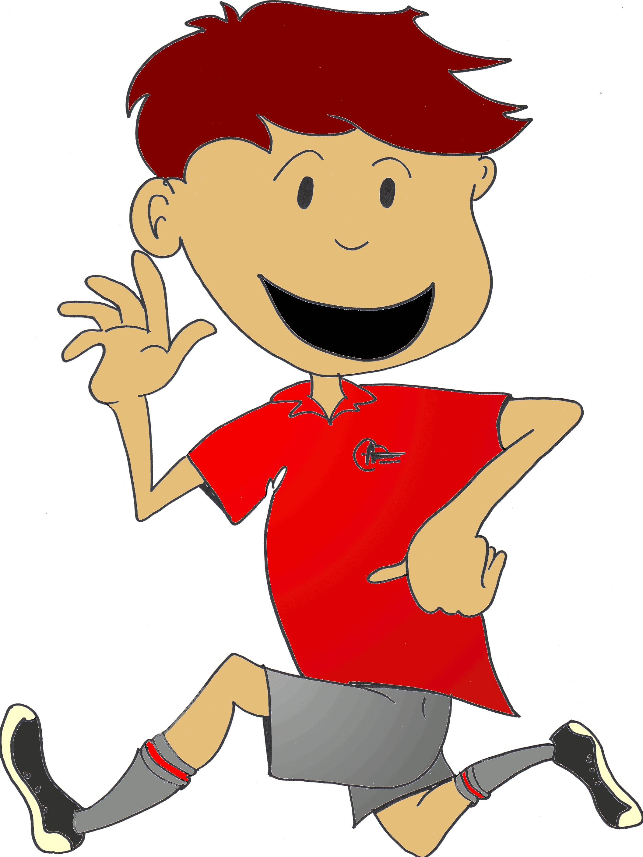
TARADALE INTERMEDIATE PB4L BEHAVIOUR EXPECTATIONS MATRIX
TIS  MATRIX | BE SAFE | BE RESPECTFUL | BE A LEARNER
AT CAMP | - Use equipment carefully  - Follow instructions the first time  - Keep within the boundaries  - Wear the correct gear | - Consider others  - Respect and care for the environment  - Use manners  - Listen actively | - Ask questions  - Listen actively  - Take responsible risks  - Contribute  - Be organised
EOTC/SPORTS TRIPS | - Keep with the group  - Watch for traffic  - Listen to the adult/teacher  - Wear the appropriate gear | - Wear uniform correctly  - Move aside for pedestrians  - Listen and follow instructions/directions  - Use appropriate language | - Listen to the leader/coach  - Learn from your mistakes  - Learn rules and apply them
THE PLAYGROUND  Field | - Play contact games in the right area  - Use the equipment properly  - Stay in the boundaries | - Be aware of others space and games  - Respect and look after the equipment | - Listen to the duty teacher  - Learn new skills/games
Turf | - Use equipment appropriately  - Play sensibly  - Only go on roof if asked by a teacher  - Be alert around you | - Share and respecting area  - Listen to others  - Look after the equipment  - Report damage to equipment  - Use respectful language | - Listen to game instructions  - Learn new skills  - Interact positively with others
Other Areas | - Walk only  - Use equipment appropriately  - Keep within boundaries | - Take care of the equipment/know where to use equipment  - Use appropriate language  - Play fair/be considerate of other people | - Consider and use habits of mind  - Listen to instructions  - Use resources appropriately
TOILETS | - Wash hands  - Walk only  - Play away from the toilet area | - Flush the toilet  - Use equipment appropriately  - Respect others privacy  - Report damages or vandalism | - Be hygienic  - Train yourself to go at appropriate times
LEARNING SETTINGS | - Follow directions/respect the learning environment  - Share and collect equipment safely  - Be aware of others and their needs as learners | - Respect others’ rights to teach and learn/  - Be a good listener.  - Allow others to feel safe. | - Appreciate the learning environment.  - Have a positive, can do attitude.  - Use your Habits of mind to help you be a learner
Cybersafety | - Use appropriate internet safety  - Report anything inappropriate you come across  - Use polite language, being aware of others | - Be aware of and use respectful language  - Treat others respectfully  - Respect equipment and use appropriately | - Use the internet for school learning  - Use the ICT resources to help your learning and learn new skills along the way
VISITING ADULTS | - Give way to all adults when walking around the school, especially in doorways  . | - Be aware of and use respectful language.  - Treat all adults respectfully.  - Greet adults by saying hello and smile. | - Listen to what adults have to say.  - Involve yourself as a learner.
MOVING AROUND SCHOOL | - Walk safely and sensibly  - Walk quickly in 2 quiet class lines, stick to the left and look where you are going  - Keep within the designated boundaries | - Be quiet around other classrooms  - Be aware of others using footpaths/other spaces  - Be on time and be where you are meant to be | - Learn and follow expectations for moving around the school  - Be aware of your actions and how they impact on others
TRANSITION TO AND  FROM SCHOOL | - Know and follow the road rules for pedestrians and cyclists when coming to and from school  - Be considerate of other users on the footpath and road  - Keep yourself safe | - Be aware of and use respectful language  - Treat others respectfully  - Remember you share the footpath/road with others, so keep to the left  - Wear your uniform correctly | - Learn how to ride a bike correctly and follow the road rules  - Action safety messages  - Be a courteous user of the footpath/road
ASSEMBLIES | - Keep to your own personal space and be aware of others  - Walk silently into assembly and sit quietly.  - Be sensible | - Be a respectful and responsive audience who know when to listen  - Be attentive listeners  - Stand and sit according to expectations | - Listen and participate when/where appropriate  - Involve yourself as a learner
OFFICE | - Use the correct entrance  - Wait patiently and politely, for an adult to help you | - Wait your turn and use your manners  - When asked, use polite language and state clearly the reason you are there  - Be courteous to all adults and others | - Know what and how you are meant to behave in the office  - Know where to put money, notices and envelopes. If necessary ask for help by speaking to the office ladies
SICKBAY | - Enter the sickbay and knock on the office door to gain an adults attention  - Go by yourself, unless you are concerned for your health take a buddy with you  - Let others, especially a teacher, know that you are going to the sick bay | - Be quiet and patient as there may be others that require attention before you  - Be considerate of others around you | 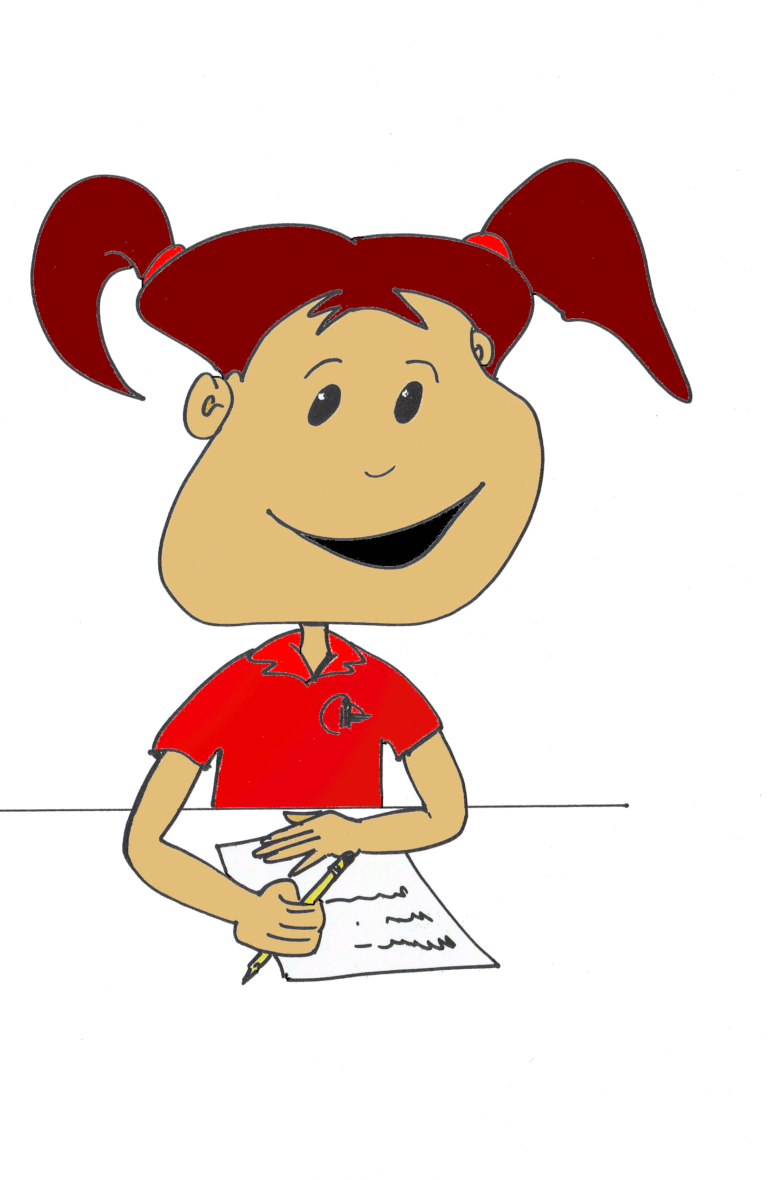  - Only be in sick bay if you are sick and need to be there  .

